Nama : Nico Arie Angga Barus

NPM : G1D021065

Mata kuliah : Optimisasi

Link GitHub :

**Soal**

Consider the optimization problem

minimize

subject to

Make a sketch of the feasible set. For each of the following objective functions, give the optimal set and the optimal value.

(a)

(b)

(c)

(d)

(e)

**Penyelesaian :**

*Source code* yang digunakan:

using JuMP

import Ipopt

model = Model(Ipopt.Optimizer)

@variable(model, x1 >=0)

@variable(model, x2 >=0)

@constraint(model, 2*x1 + x2 >=1)

@constraint(model, x1 + 3*x2 >=1)

@objective(model, Min, x1+x2)

optimize!(model)

@objective(model, Min, -x1-x2)

optimize!(model)

@objective(model, Min, x1)

optimize!(model)

@objective(model, Min, max(x1,x2))

optimize!(model)

@objective(model, Min, x1^2+9x2^2)

optimize!(model)

**Lampiran**

(a)

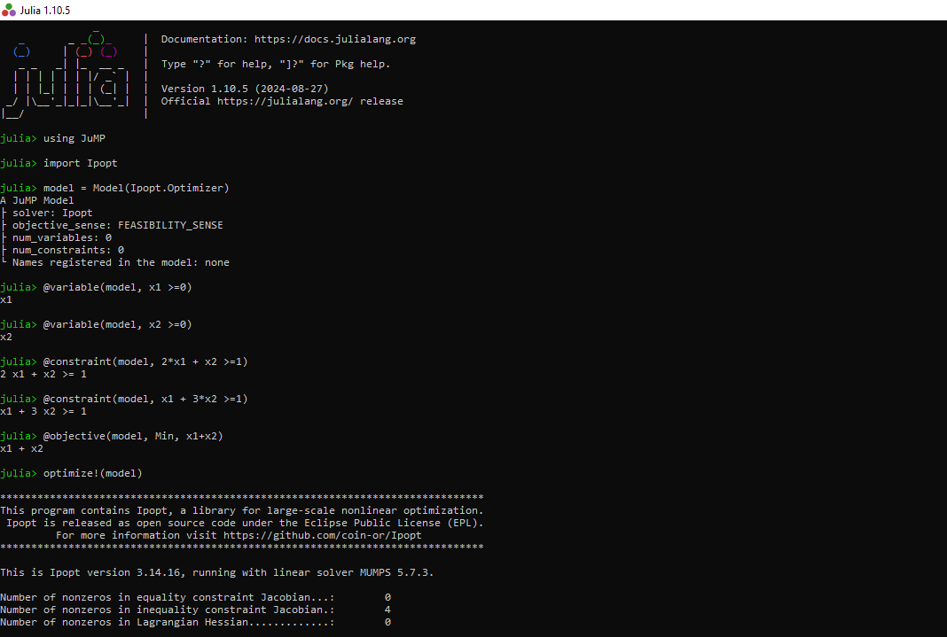

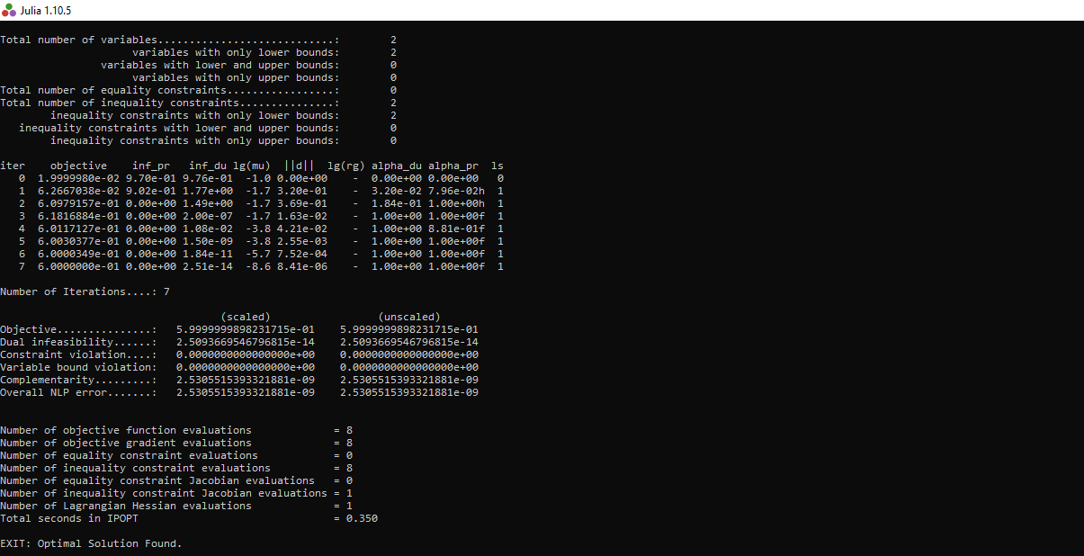

(b)

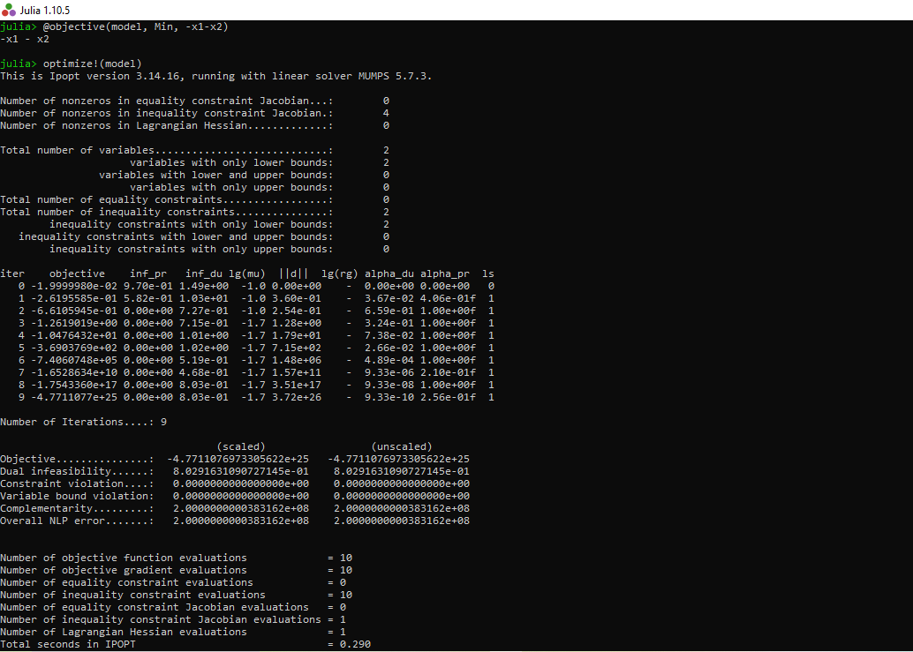

(c)

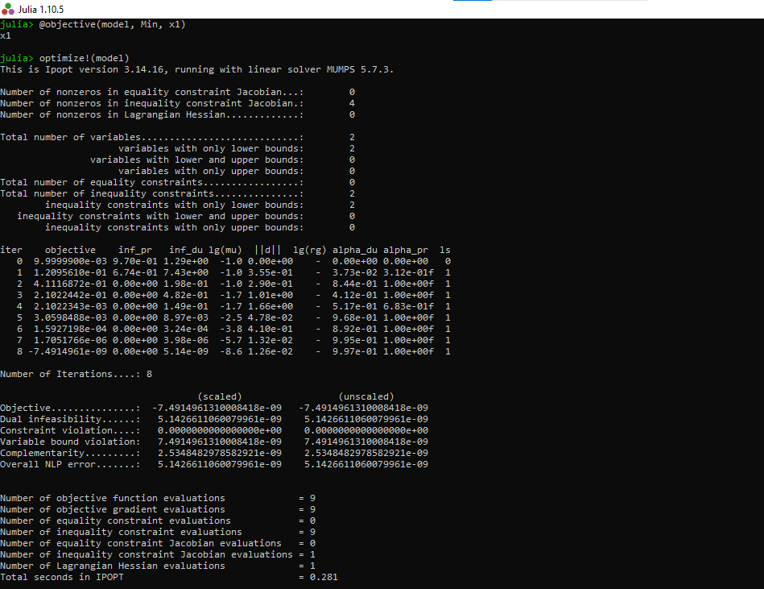

(d)

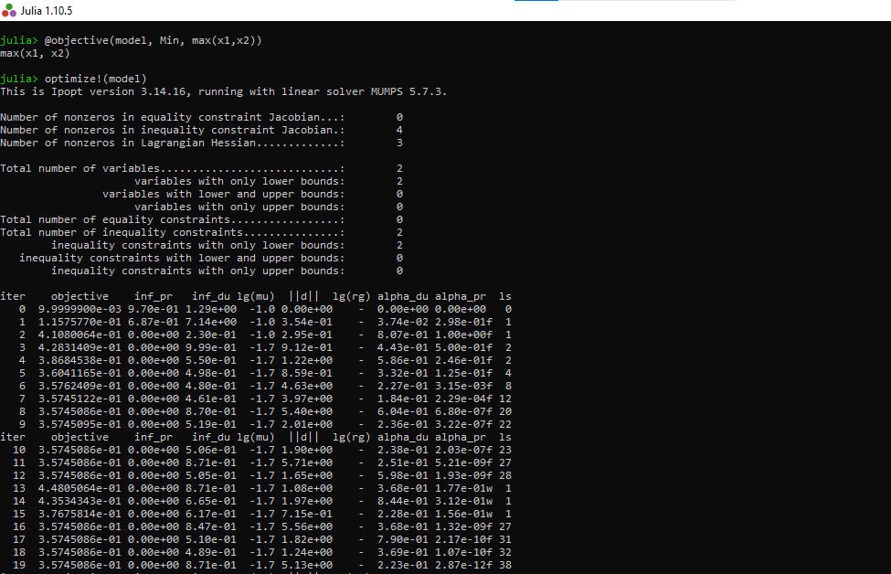

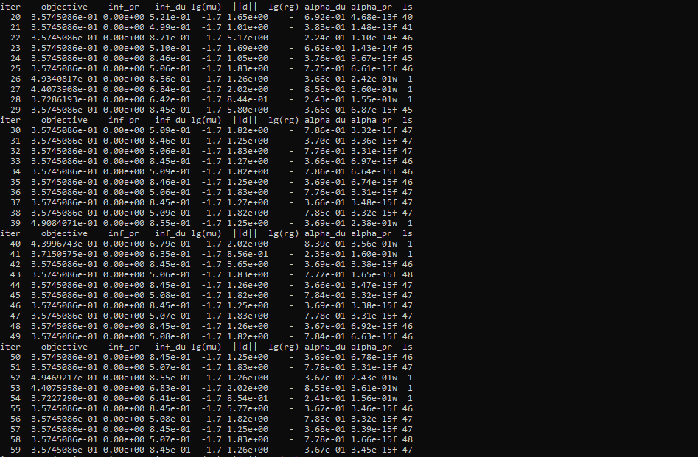

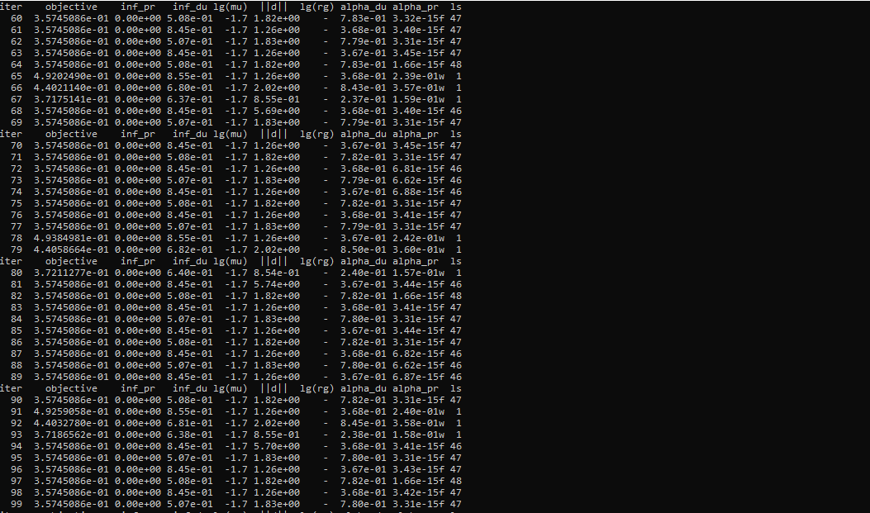

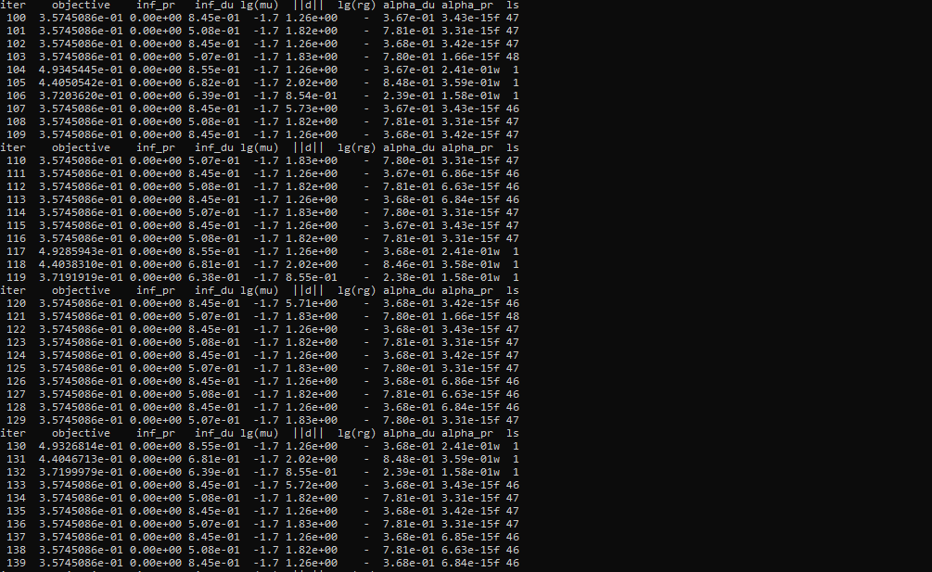

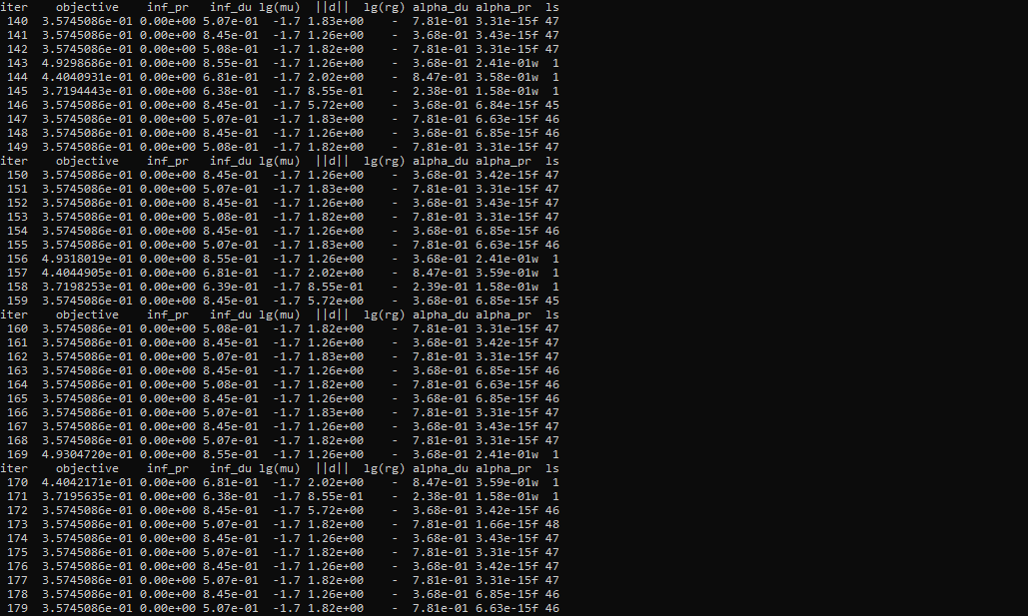

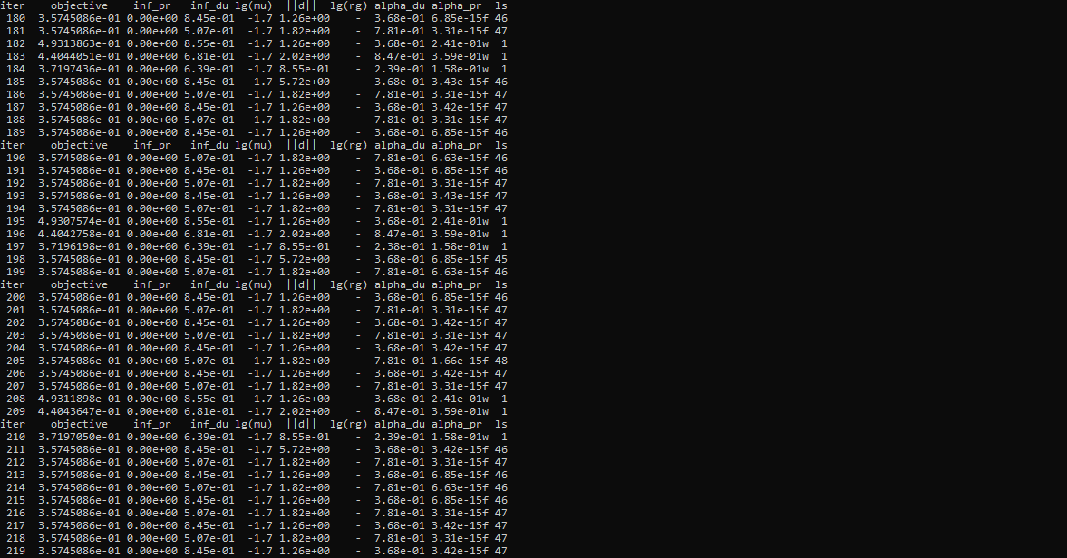

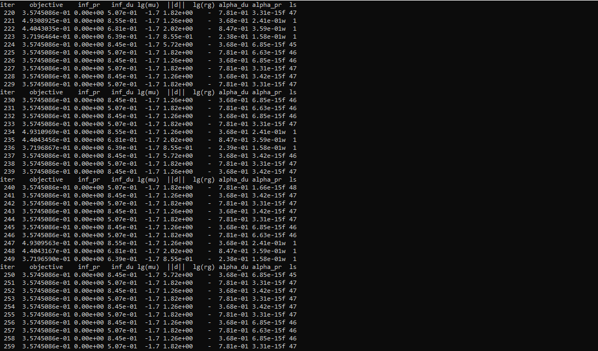

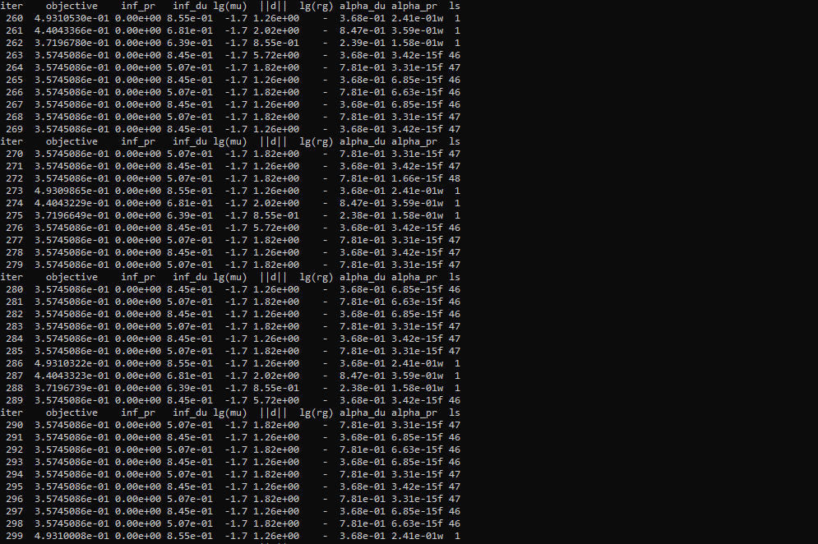

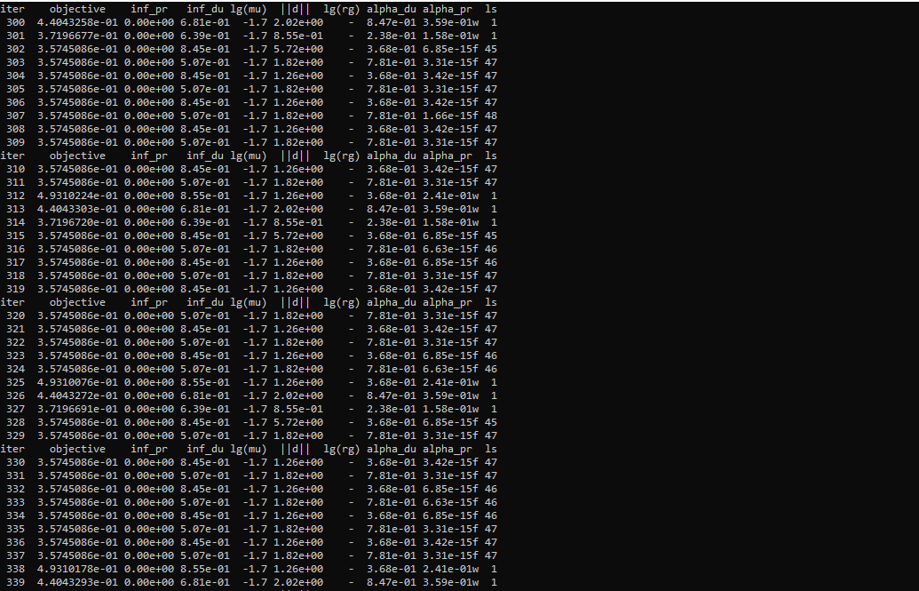

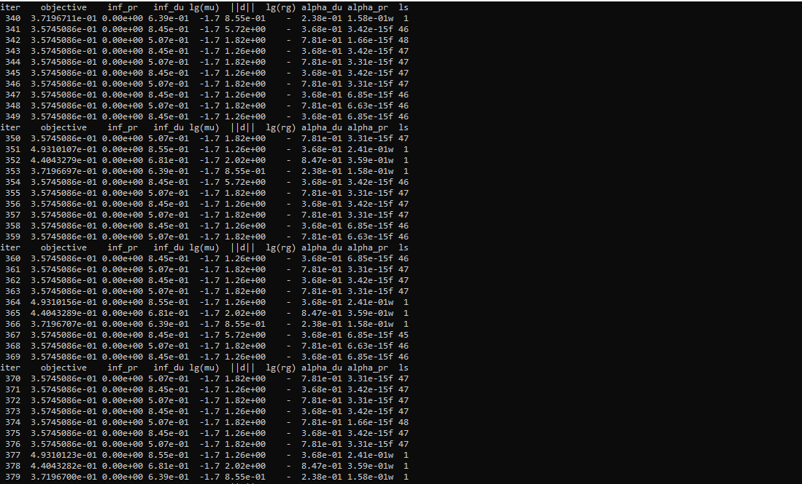

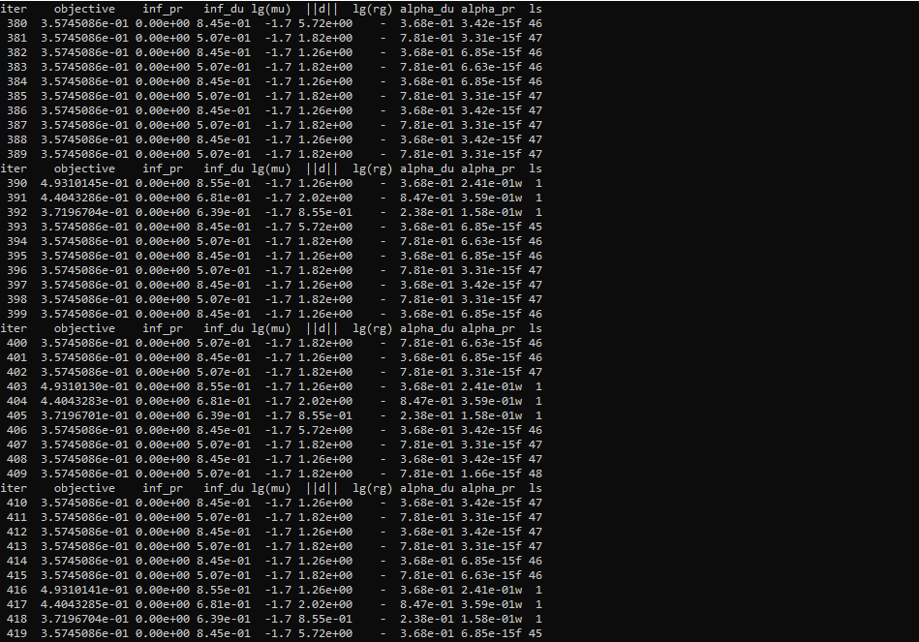

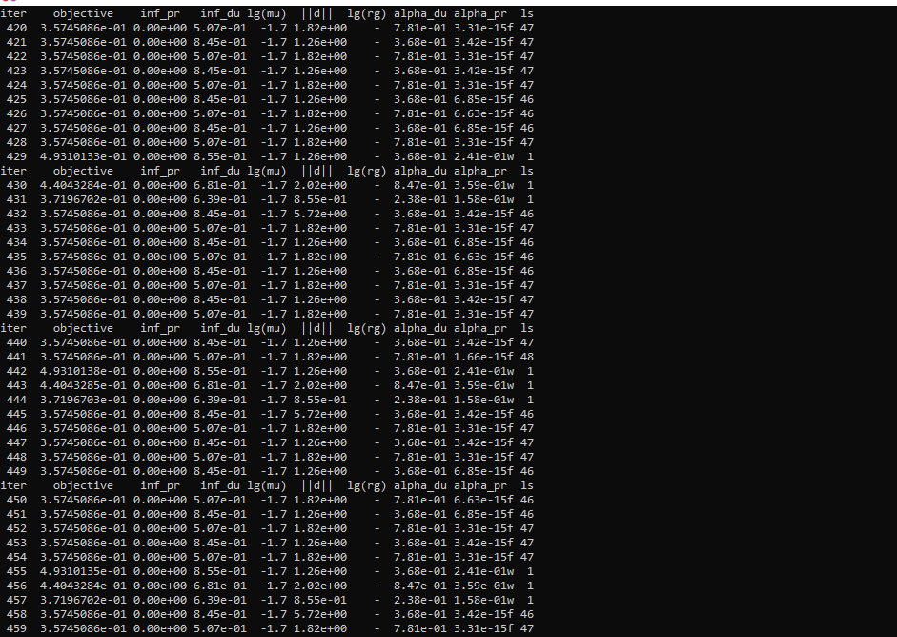

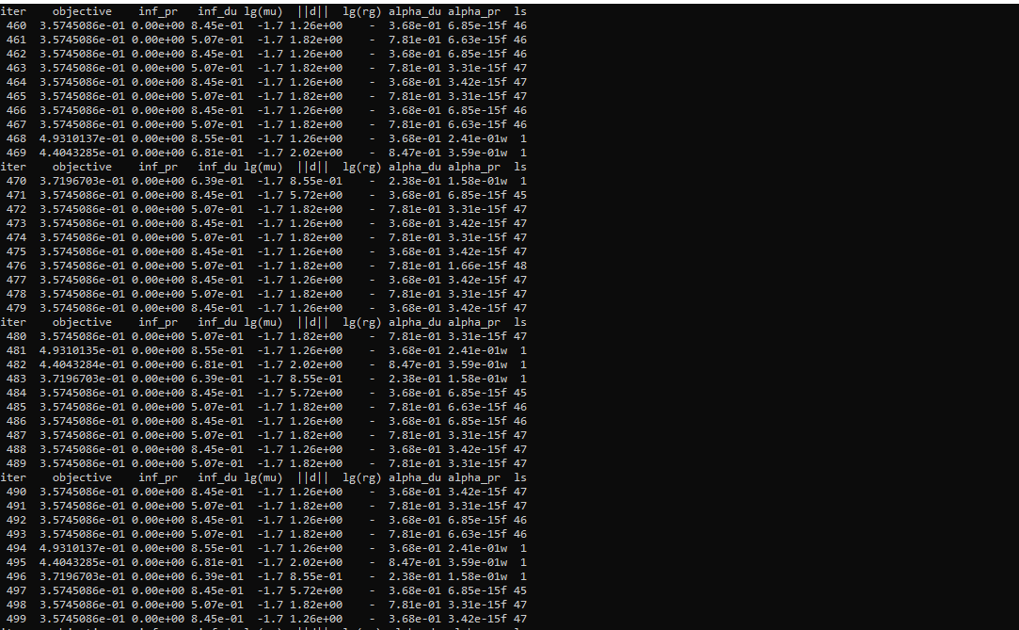

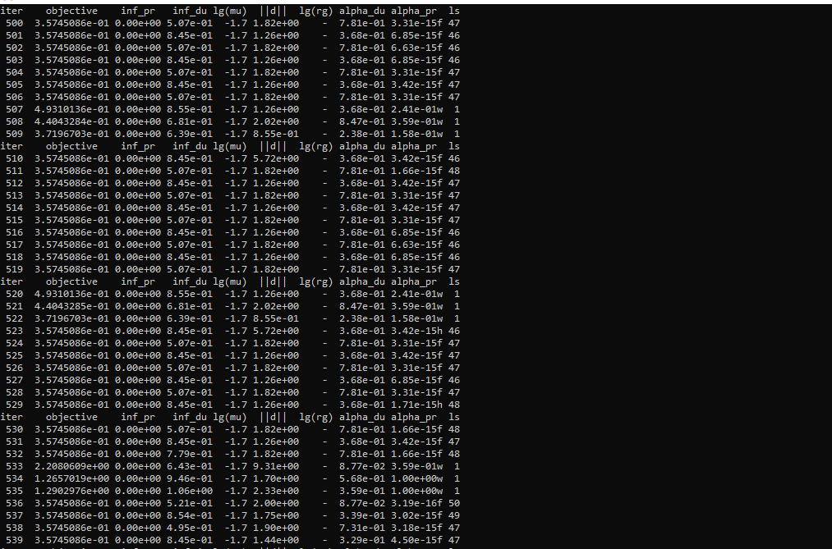

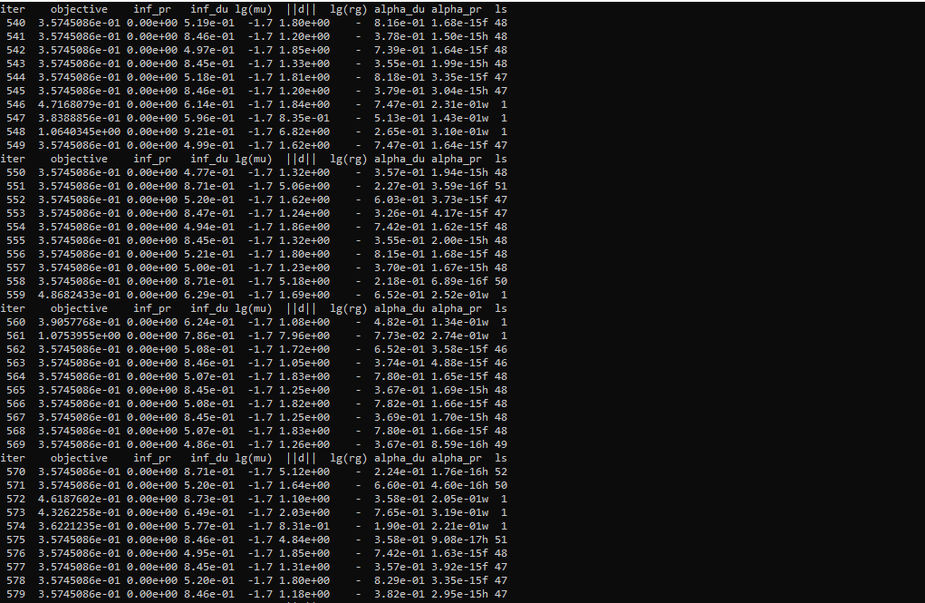

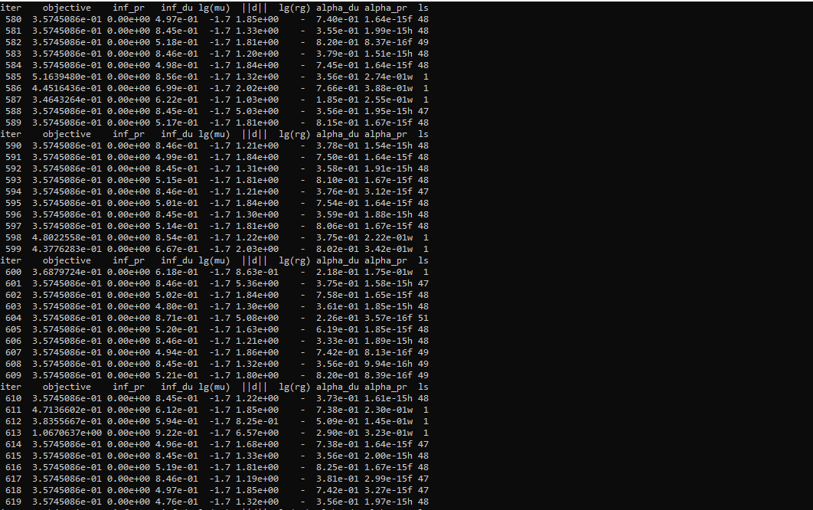

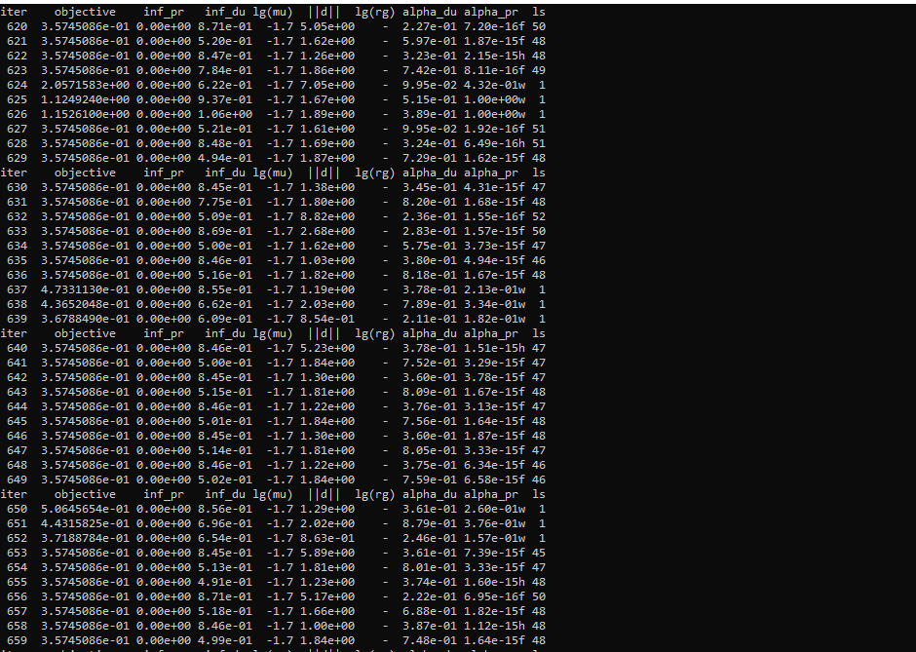

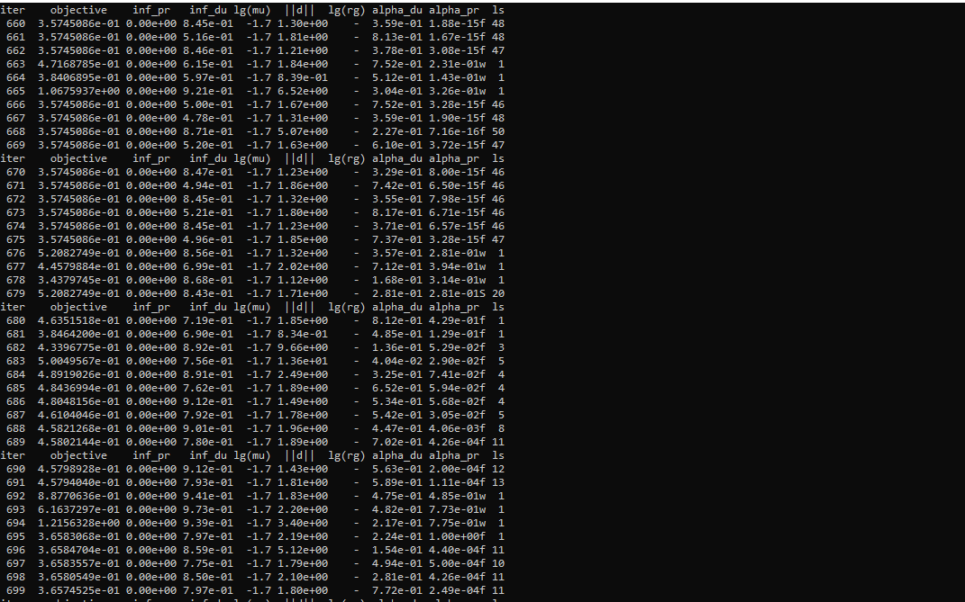

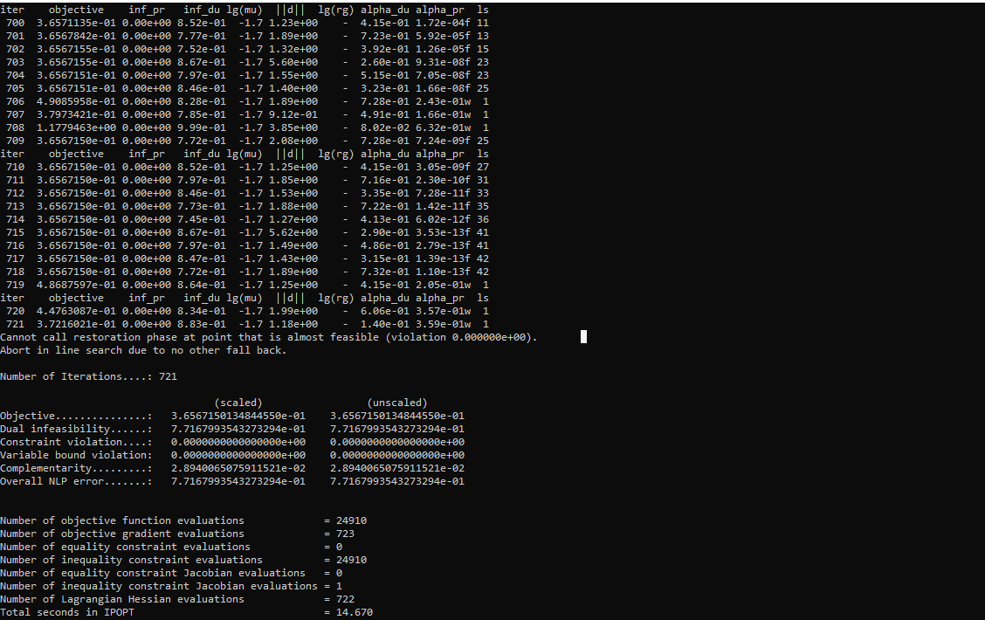

(e)

